Honohina Cemetery or Honohina Graveyard

by
Bob Nishimoto, Honohina Hongwanji

During the reign of King Kamehameha III (1825-1854), whaling ships in the north Pacific Ocean all used Hawai’i to replenish supplies, greatly boosting Hawaii’s economy. But in the late 1860’s whales were becoming scarce due to overfishing and the new petroleum industry replaced whale oil as a source of cheap lubricant. By 1870’s the Golden Age of Pacific Whaling disappeared. Fortunately for the Kingdom, businesses like C. Brewer, developed a more stable industry more adapted to the island climate and soil. This was the birth of the sugarcane industry in Hawai’i. With more lands cleared for cultivation, demands for labor became chronic. The first source of Japanese laborers were the Gannen Mono (First-Year people). Working and living conditions for Japanese laborers were severe. In 1904 a labor protest strike broke out at Waipahu Plantation. Police were called but were unsuccessful in stopping the riot. Bishop Yemyo Imamura was asked to intervene. He successfully calmed the workers by reminding them of Amida’s love and to always follow Buddhist teachings. In spite of protests by Christians, plantation managers came to recognize the importance of Buddhism to immigrant sugar laborers and cooperated fully to build community temples across the state.

As the sugar industry expanded along the Hamakua coast, so did the need for laborers. Membership at the Honomu Hongwanji expanded so rapidly that a Umauma-Honohina-Kahuku-Ninole branch was created in 1899. In 1914 this branch was officially recognized and became the Honohina Hongwanji. A small temple was built in 1916 in Honohina Town and later an adjoining minister’s residence. An associate temple was built in Ninole in 1927 to accommodate those living further north. As membership expanded, so did the need for a much larger main temple building. A beautiful temple was built mauka of the original temple site in 1937.
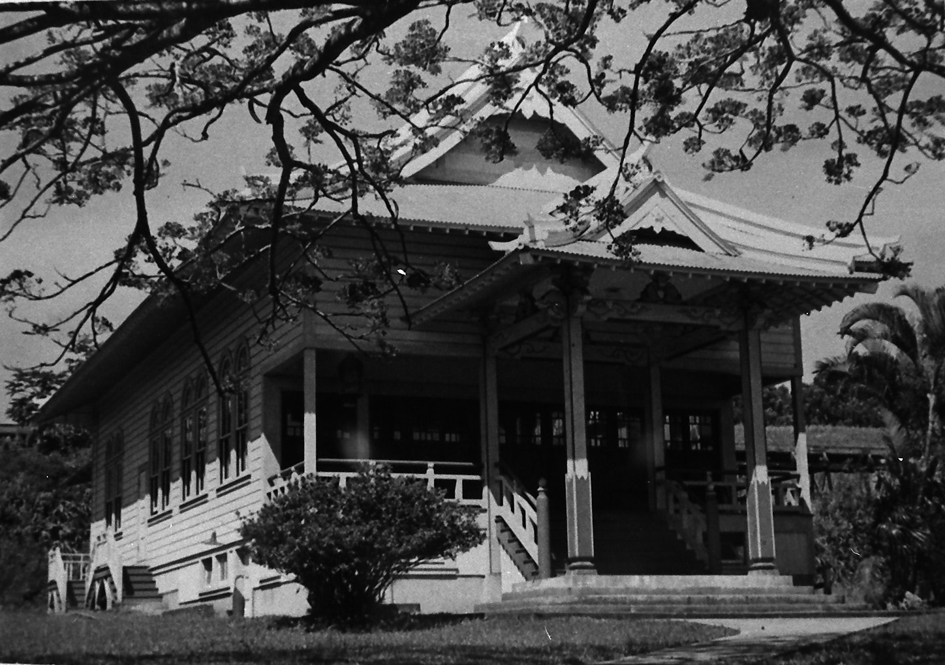
During plantation days many families buried their deceased in their yard (some islands in Polynesia still today perpetuate this practice). I remember my father and other temple men exhuming a grave in Yoban (Camp 4, Ninole) and moving it to Honohina, although Alae Cemetery was available.

Historically, deceased family members were buried at home, then later in graves on church/temple grounds. Access was only to church members or from the same religion. The word grave- comes from the German word, to dig, and the word -yard refers to churchyard. Honohina Cemetery is an example of a true graveyard. Most everyone buried there had their Buddhist name inscribed on their headstone, meaning that they were either members of the temple or Buddhists. As public demands for burial plots grew, so did the need for more burial plots open to the public and not connected to any religion or church/temple. This is why Alae and Homelani, open to all burials, are called cemeteries and not graveyards.

Honohina town disappeared when the sugar industry left Hawai’i. The only remaining relic in Honohina is the cemetery. If the cemetery is renamed Honohina Graveyard, history will remember it as being part of the larger temple grounds. The Honohina Hongwanji temple will not be forgotten, along with contributions by the Japanese immigrants to Hawaii’s sugar plantation history.
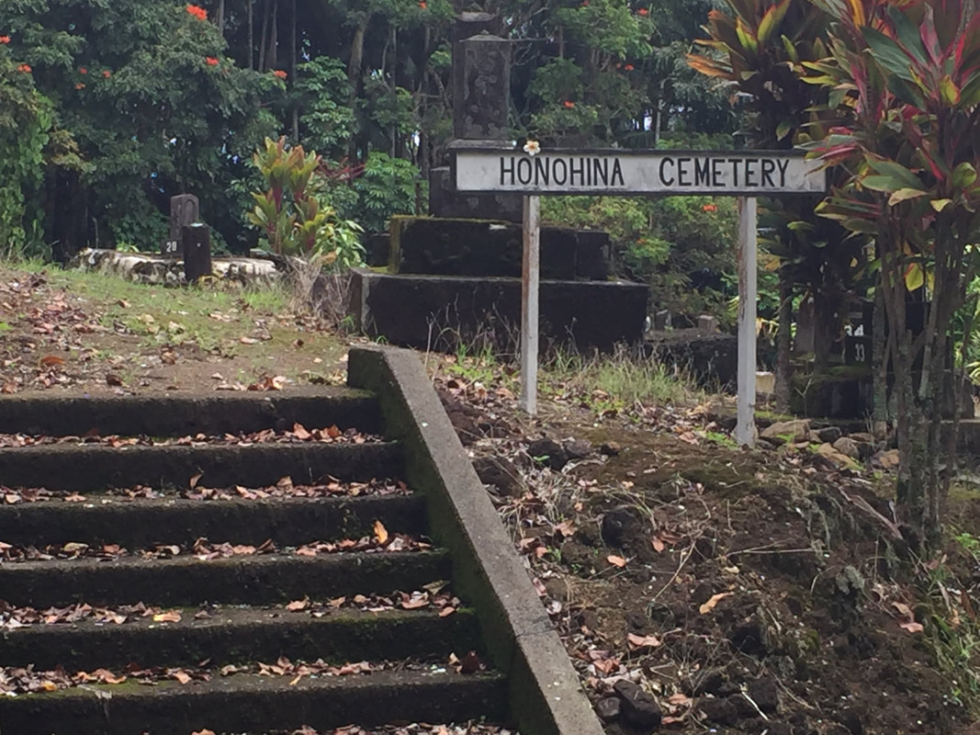
Some temple members may be uncomfortable using the word Graveyard and prefer a more neutral description, Cemetery. Is it because we are influenced by western perception (eg. Halloween, Graveyard Shift) of graveyards being ghoulish, scary, threatening? Then ask yourself, why do we continue celebrating Obon? I have attached 2 cartoons as reference.

